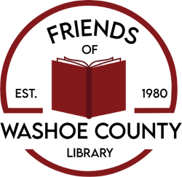

I want to be a friend of the Washoe County Library!

Name _________________________________________________

Address ________________________________­­­­­­­­­­­­_______________

City ____________________ State _______ Zip ______________

Email _________________________________________________

Home Phone __________________________________________

Cell Phone ____________________________________________

___ $5,000 or more (Life Member)

___ $1,000 or more

___ $500 or more

___ $250 or more

___ $100 or more

___ $50 or more

___ $35 or more (Basic Family/Couple)

___ $25 or more (Basic Individual)

___ $15 Senior (65+) or Student (Individual)

Please list all names to appear on cards:

_____________________________________________________

_____________________________________________________

_____________________________________________________

Please make checks payable to: FWCL

Mail to:

Friends of Washoe County Library

P.O. Box 7103

Reno, NV 89510-7103

The Friends of Washoe County Library is a 501(c)(3) Nevada nonprofit organization dedicated to advocating, fundraising, and providing support to the Washoe County Library System, Reno, NV. Contributions or donations may be tax deductible under provisions of the Internal Revenue Service Code of 1986, 26 U.S.C. 170. Our Tax ID No. is 94-2747114.